**TRANSFORMATIONS**

Instructions:

Please share your answers filled inline in the word document. Submit code files wherever applicable.

Please ensure you update all the details:

**Name: ___Seema Iyengar_____**

**Batch Id: ___EDA_06042023_10AM___**

**Topic: Data Pre-Processing**

**Problem Statement:**

Everything will revolve around the data in Analytics world. Proper data will help you to make useful predictions that improve your business. Sometimes the usage of original data as it is does not help to have accurate solutions. It is needed to convert the data from one form to another form to have better predictions. Explore various techniques to transform the data for better model performance. you can go through this link:

<https://360digitmg.com/mindmap-data-science>

1. Prepare the dataset by performing the preprocessing techniques, to have the data which improves model performance.

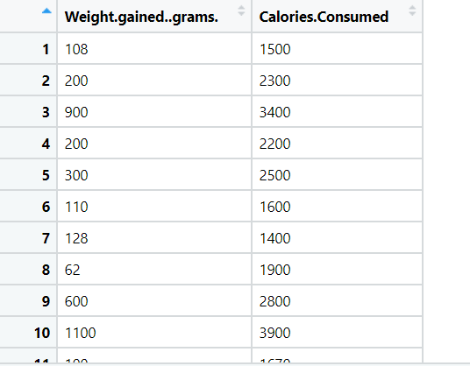

**Hints:**

For each assignment, the solution should be submitted in the below format

1. Work on each feature to create a data dictionary as displayed in the image displayed below: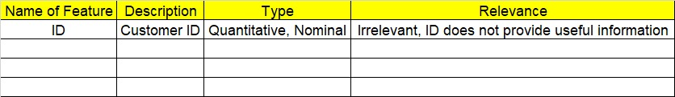
2. Hint: Refer to the calories_consumed.csv dataset
3. Research and perform all possible steps for obtaining the solution.
4. All the codes (executable programs) should execute without errors.
5. Code modularization should be followed.
6. Each line of code should have comments explaining the logic and why you are using that function.